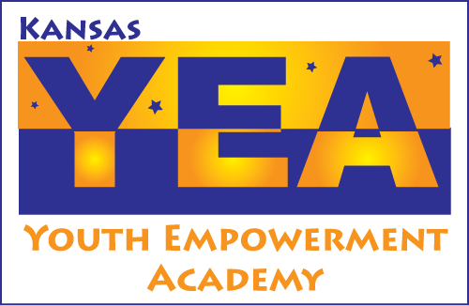

Kansas Youth Empowerment Academy (KYEA)
Board of Directors Application

Date: _______________________

 Youth (under 26 years of age)  Non-Youth

Name: _________________________________ E-mail: _____________________________

Address: _____________________________________________________________________

 Day Phone: __________________________  Evening Phone: ___________________
(Please check the phone number at which you prefer to be contacted)

The KYEA bylaws require all youth members and 51 percent of non-youth members to be people with disabilities. Do you have a disability?  Yes  No

What accommodations, if any, will you need to participate as a potential board member? ____________________________________________________________________________

____________________________________________________________________________

Your Background

Please describe your current and previous leadership and community activities?

Your Knowledge and Views of KYEA

Please write a brief statement of your understanding of KYEA’s mission and services.

What skills and expertise would you bring to continue KYEA’s growth and success?

References (Please list name, address, e-mail address, phone number and relationship to reference for each.)
1.
2.
3.

*Please e-mail completed application and current resume to Julia Connellis, Executive Director – juliat@kyea.org.

